Vegetables

  - Corn on the cob

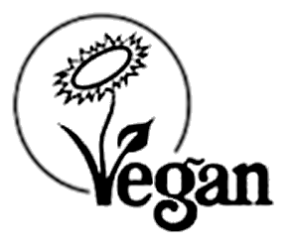

Dessert

  - Assorted
Contains eggs, cereals containing gluten, milk

Potato

  - Assorted
Contains cereals containing gluten

Salad

  - Assorted
Contains eggs, cereals containing gluten, mustard, milk

